Project Design Phase-II Customer Journey

|  |  |
| --- | --- |
| Date | 24 October 2022 |
| Team ID | PNT2022TMID39478 |
| Project Name | AI-based localization and classification of skin disease with erythema |
| Maximum Marks | 4 Marks |

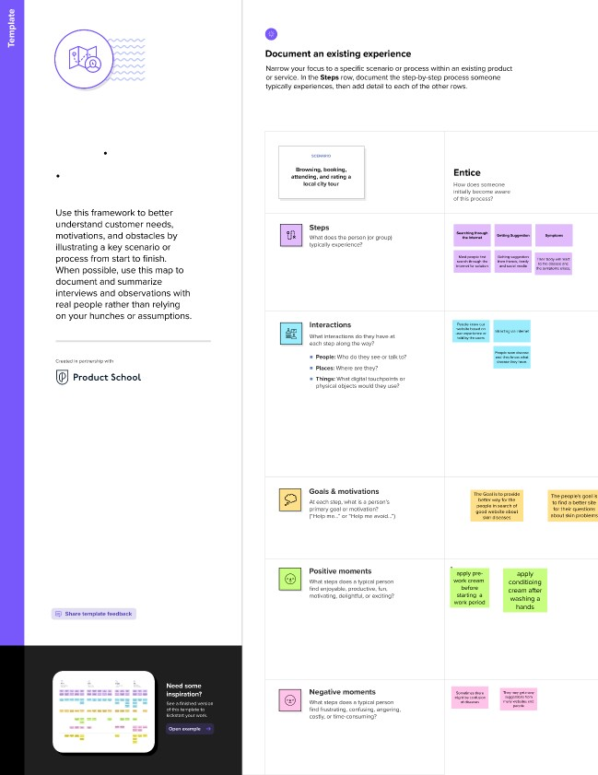

Customer experience journey map

*O*

As you add steps to the experience. move each these

-Five Es* the leh or right depending on the scenerlo you are documenting.

# Enter

What do people experience as they begin the process?

# Engage

In the core moments in the process, what happens?

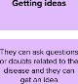    







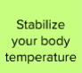





Exit

*o*

Extend



